**Day Start Operations at Branch**

* First you need to generate float (electronic money) to the Branch Cashier’s account from Dealer Portal

To do so,

Go to Dealer Portal 🡪 <https://dealer.ebirr.com> enter your username: and password

1. Click **Account Management**—> **Dealer Bank Withdraw** then as shown in the Following sample screen shoot, Select R*eceivable Account,* Enter *Amount, and* finally Enter *Description* and click on **Withdraw Money**.

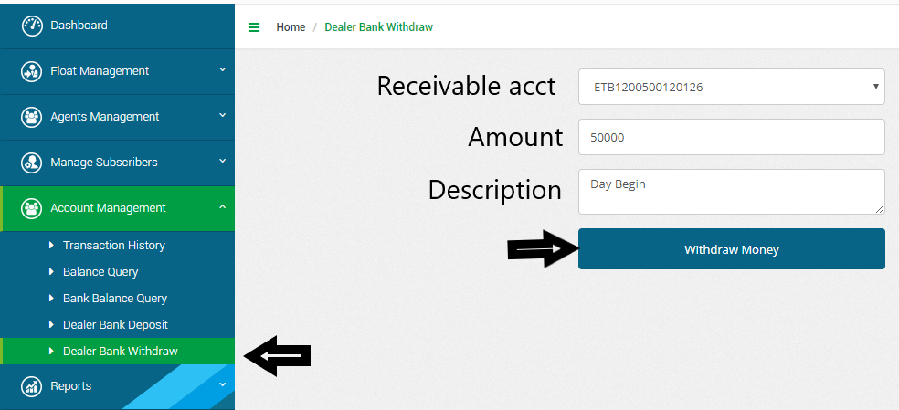

Branch Code

**N.B:1** There will be an automatic entry while dealer withdraw from bank. Which is, Receivable Account (ETB120110001XXXX) of Specific branch will be debited and Deposit account (ETB144680001XXXX) will be credited by default on CBS.

**N.B:2** In account numbers likeETB144680001XXXX and ETB120110001XXXX the “(XXXX)” represents the company code of the branch which originates the transactions.

**N.B:3** Receivable accounts should ***always be zero*** at the end of operation date.

2. To move float to Agent (Teller) from Dealer Portal

To do so,

**On Dealer Portal**

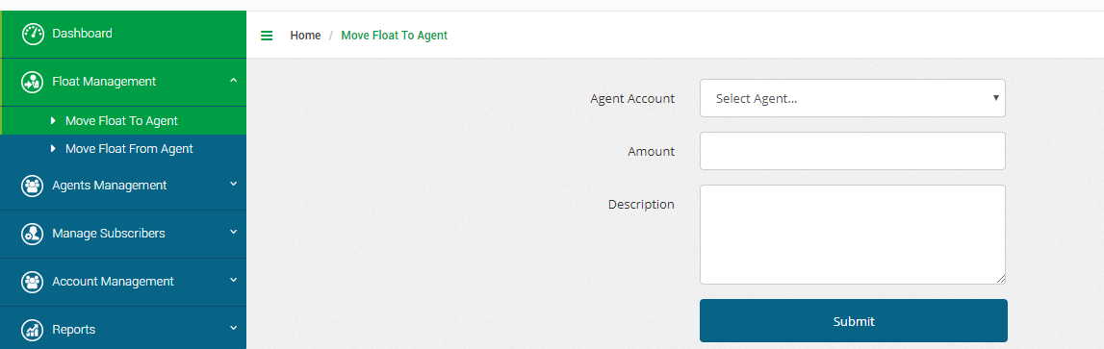Click, **Float Management**->**Move Float To Agent** (Teller) then as shown in the Following sample screenshot, select Agent(Teller), write Amount you want to send to teller, write description and finally click **Submit**

When you click on submit the following screen will be displayed.

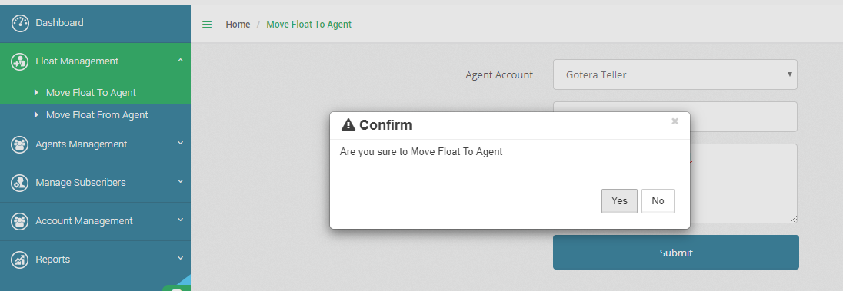

If you are sure to Move Float to Agent (Teller) click on “Yes” then you will get the following screen.

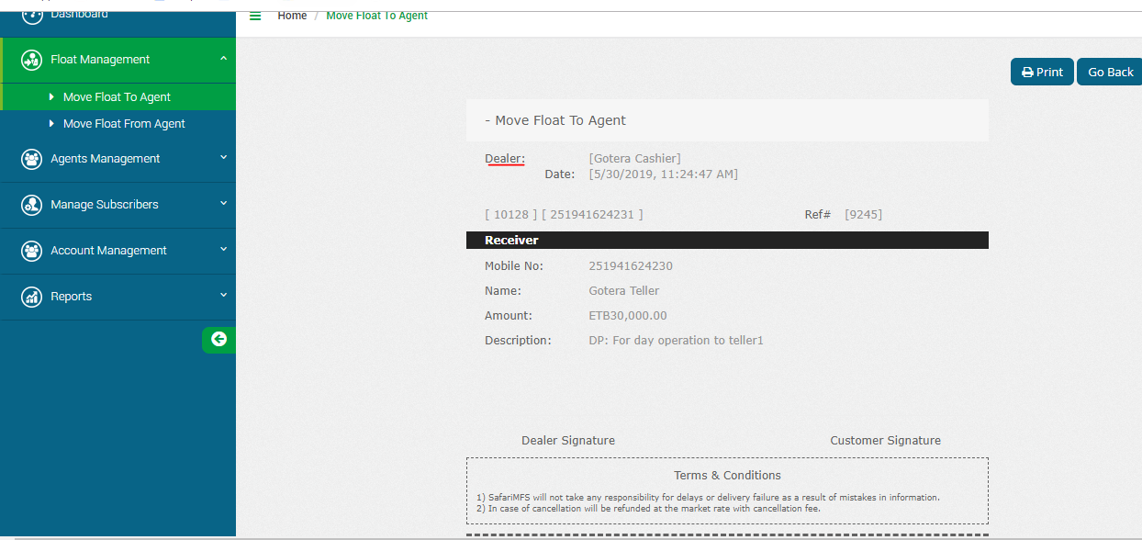

**On Agent Portal**

3. Check balance sent from Dealer (cashier) on Agent (Teller) portal to start operation.

To do so,

Go to Dealer Portal 🡪 <https://agent.ebirr.com> enter your username: and password

* Click **Manage Account** ->**Balance Query** then select Teller and click on **Balance**.

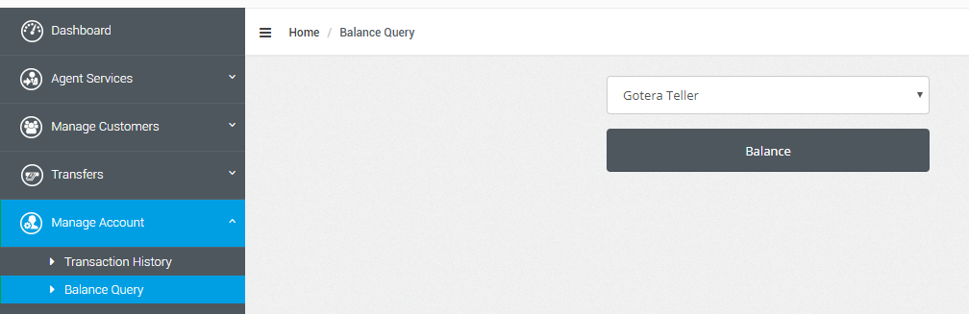

* When you click on “Balance” the system display the balance the teller has, as shown below.

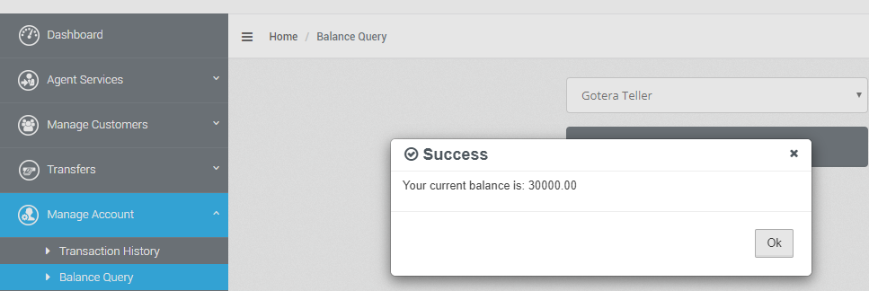

**4. Now the teller can start operation.**

4.1 Customer Deposit (ETB200.00 in cash)

On CBS (T24)

A. On CBS the teller shall pass the following Transaction

* Debit Account Cash------------------------------------------------------------ 200.00
* Credit Account “**COOPay Ebirr Receivable(ETB120110001XXXX)**” -------200.00

On Agent Portal

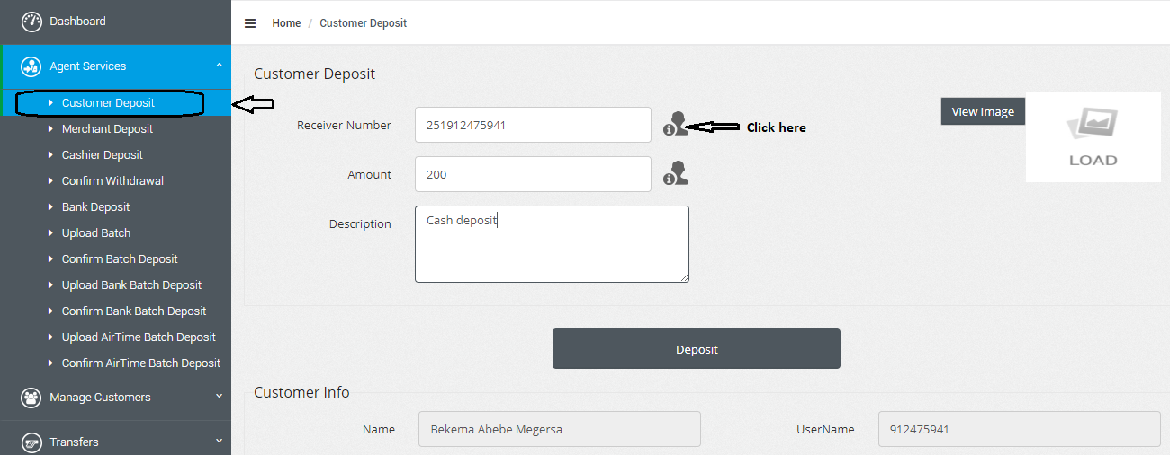B. On Agent portal, Click **Agent Services**->**Customer Deposit** andfill **Receiver mobile Number, write Amount, Write Descriptions** and thenclick **Deposit.**

As you Click on the Deposit button the following screen will be displayed.

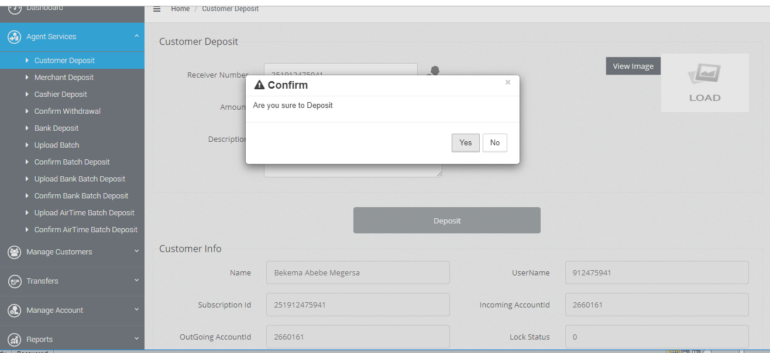

If you click on “**Yes”** the following slip will be displayed. Print and give it the to customer, if requested.

4.2 Customer withdraw (ETB100.00 in cash)

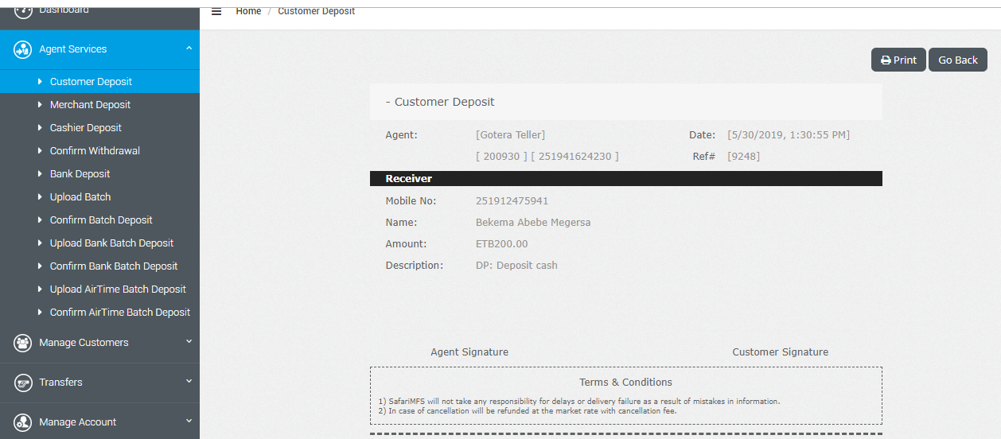

**On Customer Portal (It could be USSD or Application)**

The beneficiary withdraws money by writing Agent ID (Teller Id) and amount he/she want to withdraw, and then click on Submit. The screen will be displayed here under.

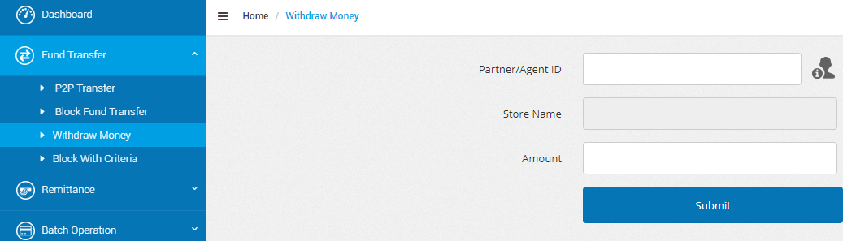

The Agent (Teller) confirms withdrawal to pay cash.

**On Agent Portal**

**Agent Service** ->**Confirm withdrawal.** The screen will be displayed here under.

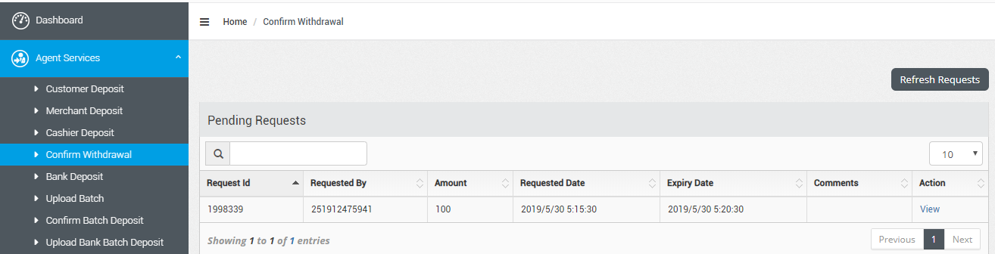

While click on **view** the following screen will be displayed. You can check by clicking on view Customer image and write Reason field and Accept Request.

**N.B:4** If the Agent (teller) did not Accept the request within 5 minutes the transaction will be expired and the customer needs to generate a new transaction by customer to the Agent(Teller).

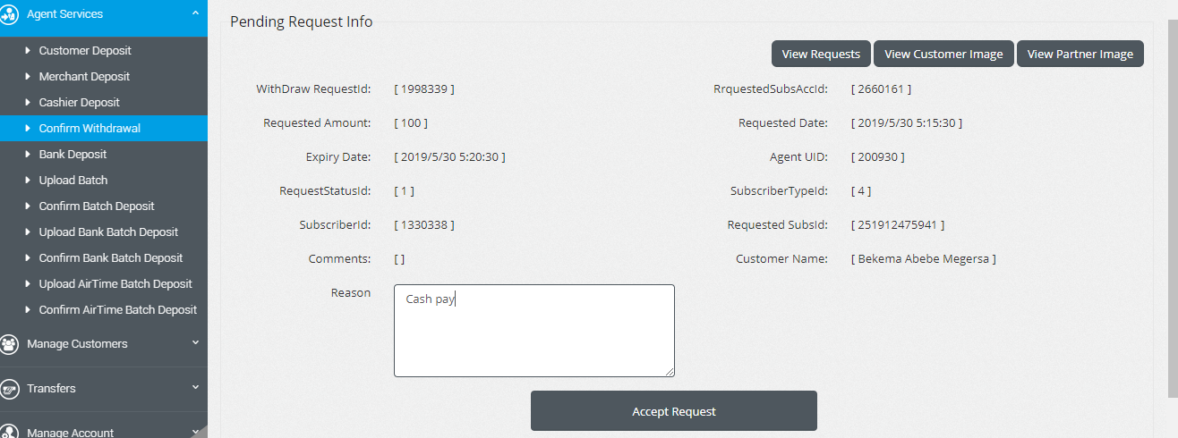

After writing the narration (reason) If click on **Accept Request,** the below screen will be displayed.

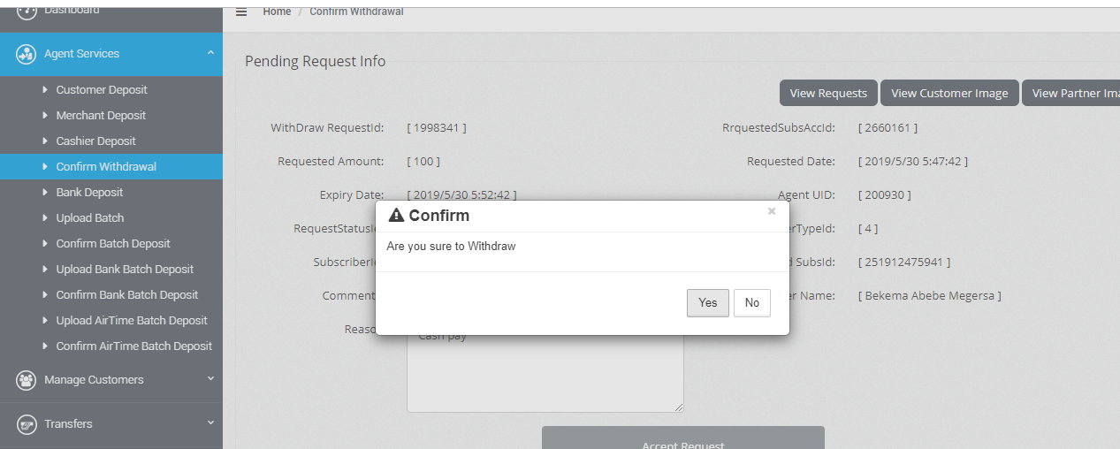

If click on “Yes” the screen below will be displayed.

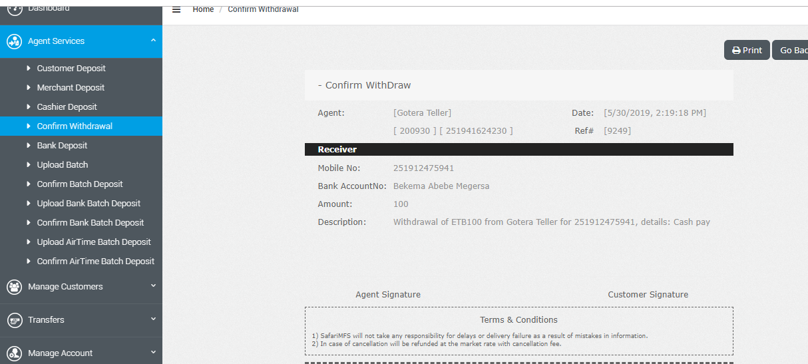

If Agents want to see her/his float balance go to **Manage Account**->**Transaction History**->*Get Statement* then you will get the following screen and check sender mobile number, amount credited and your ending balance you have as per the following screen. Finally now you can pay cash

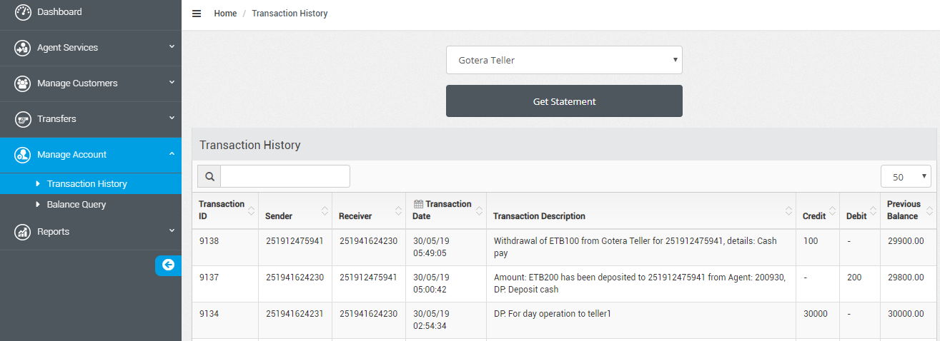

When you pay cash the entry that should pass on CBS is:-

Debit Account” COOPay Ebirr Receivable (ETB120110001XXXX)”------100.00

Credit cash by default--------------------------------------------------------------------------100.00

**To close day end Transactions**

Dealer should check Agent (Teller) Mobile money balance

To do so,

On Dealer portal Click **Agent management**->**Query Agent balance**->Select Agent (Teller)->Click on **Balance then you will get the following screen.**

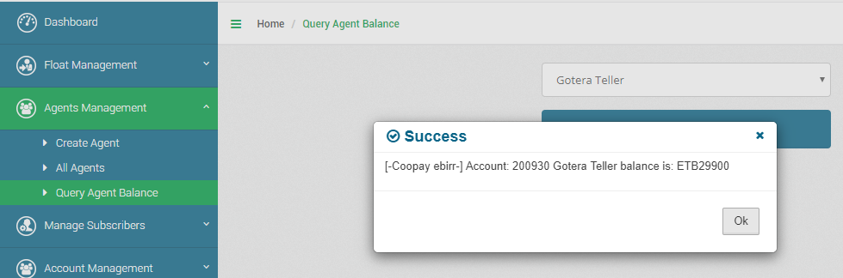

Dealer Move Float from Agent (Teller)if Float exists in Agent(Teller) wallet balance(Mobile Money).Steps to Move Float:-

On Dealer portal Click **Float Management**->Click **Move Float from Agent** (Teller) then select Agent (Teller), write **Amount** to move, write **Description** and click **Submit**. The following screen will be displayed.

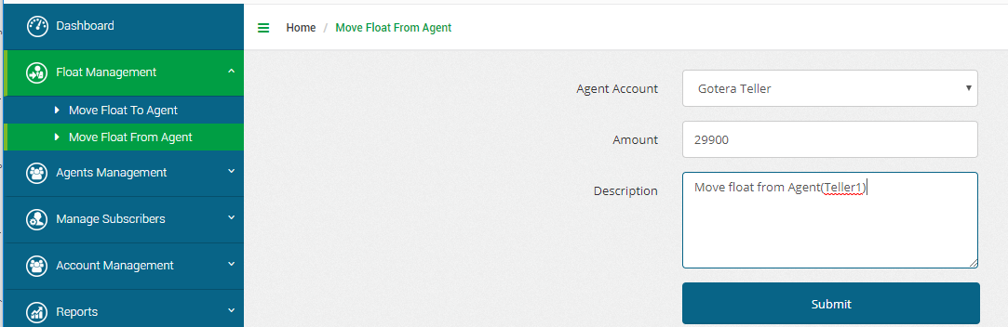

During Click on SUBMIT the following screen will be displayed

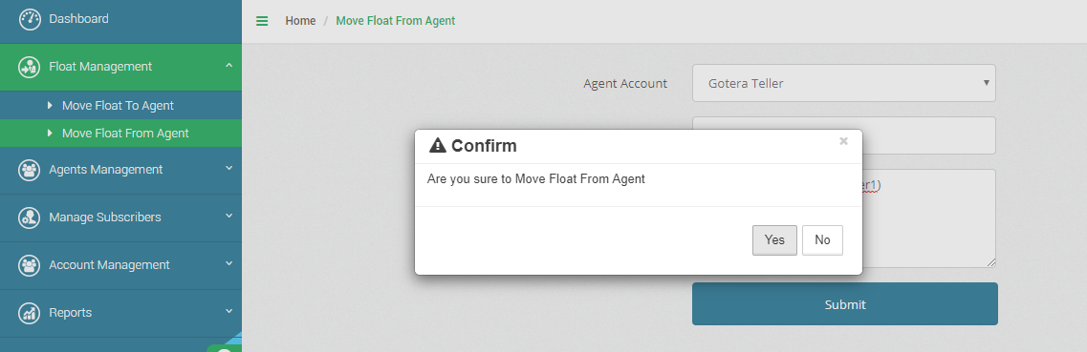

If click on “yes” the following slip displayed.

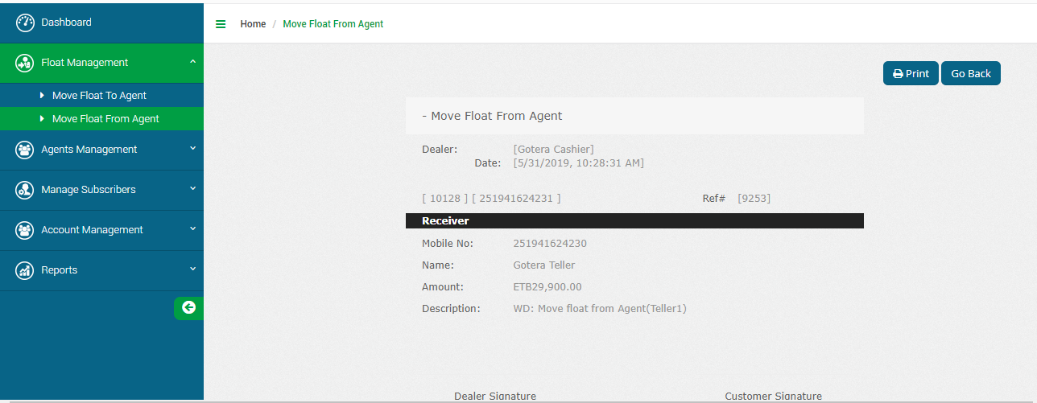

Now Agent(Teller) balance is Zero.

**To close Dealer balance**

**On dealer portal**

Click **Account Management->Click Dealer Bank Deposit then** select COOPay EbiirReceivable(ETB120110001XXXX**),**write **Amount,** write **description** and Click **Deposit Amount.**

**The following screen will be displayed.**

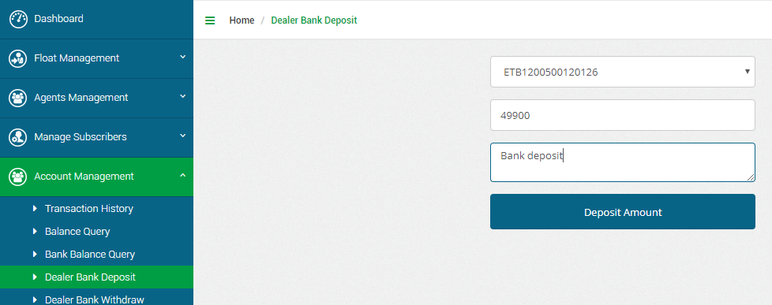

When we click on **Deposit Amount** we will get the following screen.

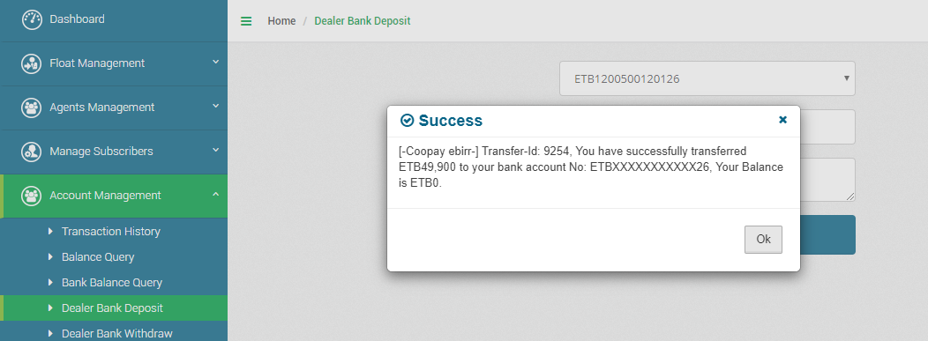

Now Dealer balance is Zero.

On CBS we have seen that The COOPay Ebirr Receivable account should be Zero and COOPay Ebirr Deposit account (ETB144680001XXXX) of branch shows the deposit amount received by Teller in a day.